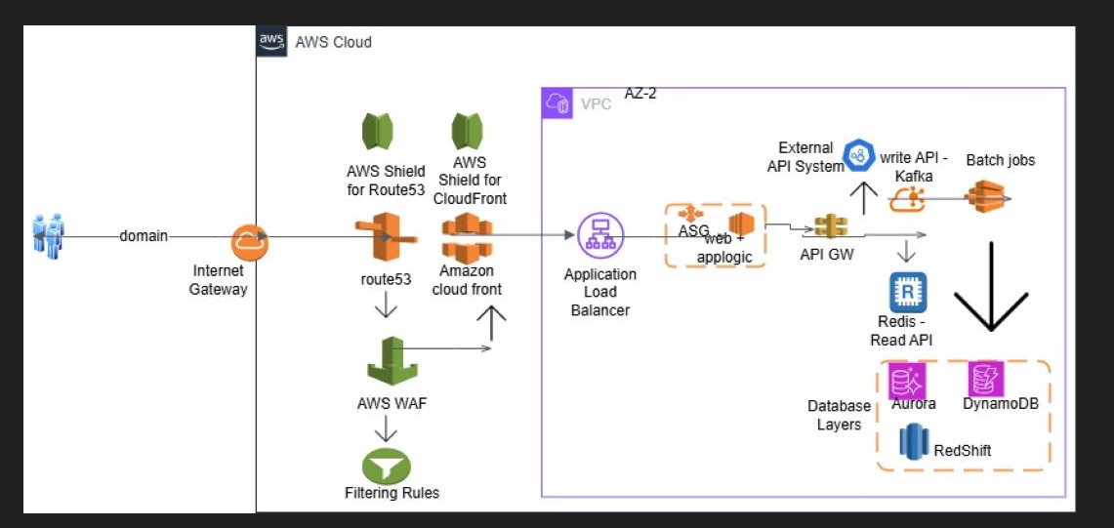

**Fig: Cloud Architecture Diagram for e-commerce**